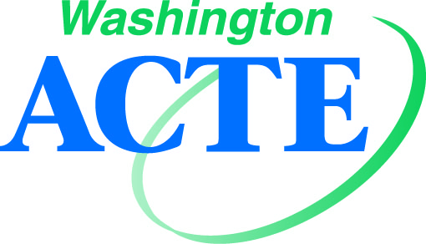
Impact Awards

Purpose: These awards recognize individuals and groups from the education, business and industry communities who enhance Career and Technical Education (CTE) by contributing to the improvement, promotion, development, and progress of CTE.

Eligibility: Candidates do not need to be members of WA-ACTE to be eligible, but they must be nominated by a WA-ACTE Section. Only one nomination for each Impact Award per Section will be accepted.

Criteria: The nominees will be evaluated on the following criteria:
- Significant accomplishments related to CTE that have contributed to the improvement, promotion, development, and progress of CTE.
- Actions that have enhanced the growth and quality of CTE.

(Note: considerations for the above can extend to sponsored programs, publications, financial support, and other activities.)

Application Requirements:
All applicants must be nominated by a WA-ACTE Section. Applications for this award must include the items below (incomplete applications will not be considered):
1. Nominator contact and membership information (all candidates must be nominated by a WA-ACTE Section.)
2. Letter of Introduction summarizing the following: (Note: letter of introduction should not exceed 350 words in length.)
• A brief overview of the applicant (i.e., short biography or background information)
- Significant accomplishments related to Career and Technical Education that have contributed to the improvement, promotion, development and progress of CTE.
- Actions that have enhanced the growth and quality of CTE.
3. Other supporting materials: additional information about achievements that have contributed to the growth and quality of CTE. (Note: not to exceed 500 words in length)
4. Letters of support: Each application requires a minimum of 2 letters of support (maximum 4) recommending the candidate as relates to the above areas. (Note: Suggested endorsers might include political leaders, professional association leaders, business and industrial leaders, educational leaders, civic leaders, parents, and students.)
5. Photo/logo: should be digital, high resolution (at least 300dpi), and submitted in .jpg format. Files 2MB or larger are preferred. (Note: photographs will be used for publicity purposes only.)

All applications should be submitted by May 1. The Awards Committee will recommend their selection to the WA-ACTE Executive Committee for approval in May. Awards will be presented to winners at the Awards Breakfast during the WA-ACTE Summer Conference.

Winning applicants permit WA-ACTE to use and edit content of the application for promotional activities.

Impact Awards

Application for:

- WA-ACTE Business-Education Partnership Award
  - Eligibility and Criteria: Eligible partnerships have been created within the last five years, are designed to support high-quality CTE programs, and exist between at least one educational institution and at least one business or industry representative group. Partnerships should be existing at the time of nomination and should have made a measurable/significant impact on student achievement and on the development of the local community and economy. Greater consideration will be given to partnerships that demonstrate sustainability and innovation (either in the partnership itself or its outcomes.)

- WA-ACTE Champion for CTE Award
  - Eligibility and Criteria: These awards are open to education leaders, business and industry executives, celebrities, thought leaders, and other individuals who have made a significant impact on the improvement and expansion of CTE programs and/or on positively influencing policymakers and public opinion regarding CTE. Greater consideration will be given to candidates who have repeatedly demonstrated their public support for CTE and who exhibit an understanding of the components of modern, high-quality CTE.

Nominator Section:

Nominator Contact Name:

Employer:

Address:

City/State/ZIP:

Telephone:

Email:

WA-ACTE Membership # (required):

Nominee Name:

Employer:

Address:

City/State/ZIP:

Telephone:

Email:

Nominations are due May 1.
Email to: taa@wa-acte.org | Fax to: 360-357-1491 | Mail to: WA-ACTE, PO Box 315, Olympia WA 98507

