Donation Request

Washington ACTE Summer Conference 2023 will be hosting a silent auction this year to raise funds for the Washington CTE Foundation. Silent Auction items will be on display Sunday, Monday, and during the awards breakfast on Tuesday morning of Summer Conference. Items will be on display in the main ballroom with a signup sheet for each item. These items need to be picked up by the winner before the conference ends.

Now we need to start gathering auction donations. Anyone can donate items for the silent auction. Examples: pottery, photographs, books, CDs, DVDs, video games, toys, games, kitchen items, wine, chocolates, weekend retreats, theater tickets, sporting event tickets, gift cards, photo albums, fragrances, jewelry, yard art, themed baskets, etc...Be creative! Donations will be picked up at the conference.

Please bring your donated items with you to Summer Conference and drop off either at the onsite registration window or at the exhibitor registration table in the exhibit hall. Money collected from the silent auction will be used to fund the Washington CTE Foundation awards and scholarship efforts.

Basket Ideas:  - Date Night  - Weekend Getaway  - Wine or Beer  - Pets  - Camping  - Movie Night  - Baby Shower  - Spa Day  - Hair/Makeup | - Beach Bums  - Car Care  - Golf/Sports  - Candles  - Chocolate  - Coffee/Tea  - Gourmet Food  - Baking/Cooking  - BBQ  - Gardening  - Man Cave

All proceeds benefit the goals and objectives of the Washington CTE Foundation.
Goal 1: Invest in Career and Technical Education (CTE) by supporting CTE entrepreneurs and students.  Goal 2: Position CTE as a leader in education reform through the development of career pathways.  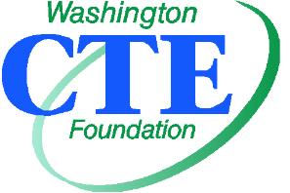 | Key Objective 1: Build support for the foundation within the CTE community.  Key Objective 2: Build partnerships with organizations that support foundation goals.  Key Objective 3: Provide grants to CTE members for innovative projects that support the development of career pathways.  Key Objective 4: Provide scholarships to CTE students pursuing postsecondary education.
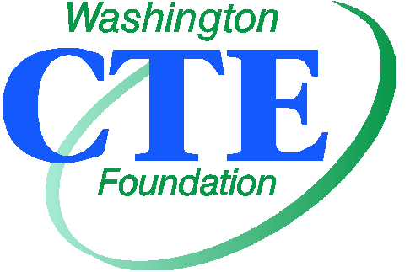

SILENT AUCTION BID SHEET

WA-ACTE SUMMER CONFERENCE

Item:

Donor:

Value: $

Minimum Bid: $

- Value of $100 to $249 – A minimum increase of $10 over the previous bid.
- Value of $250 to $499 – A minimum increase of $25 over the previous bid.
- Value of $500 and higher – A minimum increase of $50 over the previous bid.
- Items can be purchased immediately for two times their value.
- Highest written bid wins.

Bidder (print name) | Bid Amount | Bidder (print name) | Bid Amount
 |  | 13.
 |  | 14.
 |  | 15.
 |  | 16.
 |  | 17.
 |  | 18.
 |  | 19.
 |  | 20.
 |  | 21.
 |  | 22.
 |  | 23.
 |  | 24.

Auction ends after the Awards Breakfast on Tuesday.
At the close of the auction, the item will be sold to the highest bidder.
Payment will be expected upon announcement of winners.
Make checks payable to WA-CTE Foundation

