WASHINGTON ASSOCIATION FOR  CAREER AND TECHNICAL EDUCATION  WA-ACTE  PO Box 315  Olympia WA 98507-0315  360-786-9286 | taa@wa-acte.org | www.wa-acte.org | 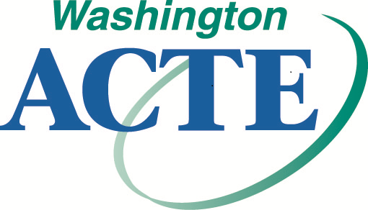 | FALL CTE CONFERENCE  Great Wolf Lodge  Grand Mound/Centralia  October 26-27, 2023 | In-Person  November 3-17, 2023 | Remote

1. CTE Section:
 WACTA – CTE Administration |  WE-BAM – Business and Marketing Education |  WAAE – Agriculture Education
 WA-CCER – Career Counseling & Employment Readiness |  WA-FACSE – Family and Consumer Sciences |  HSCTE – Health Science
 WITEA – Technology Education / STEM / Skilled and Technical Sciences

2. Name and Contact Information

Certification Number

Name (First and Last)

Badge Name (e.g. Bob for Robert) Optional Pronouns for Badge  she/her/hers  he/him/his  they/them/theirs

District School

Work Address

City/State/ZIP

Work Telephone

Cell

Work Email

Personal Email

3. Fall CTE Conference Registration (Registration includes 11 total clock hours of STEM, CTE Administration information, and WBL depending on your participation; breakfast on Thursday and Friday; and lunch on Thursday (meals for in-person).

* * * * Required:  In-Person  Remote * * * *

 WA-ACTE Member (must have expiration date of at least 12/31/2023)
$375 Through September 30 $425 October 1-23 $475 After October 23

 Non-Member (or WA-ACTE renewal)
$450 Through September 30 $500 October 1-23 $550 After October 23

4. Optional: Post-Conference early registration opportunity “Instructional Excellence” Masterclass January-May 2024 hosted by and in partnership with Catapult designed for 3-person cohorts.  Number of 3-person cohorts # x $3,000 per cohort = $

5. Section / National Memberships (optional):
 $75 WACTA – CTE Administration |  $35 WE-BAM – Business and Marketing Education |  $170 WAAE – Agriculture Education
 $25 WA-CCER – Career Counseling & Employment Readiness |  $25 WA-FACSE – Family and Consumer Sciences |  $20 HSCTE – Health Science
 $25 WITEA – Technology Education / STEM / Skilled and Technical Sciences |  |  $80 ACTE – National

6. Method of Payment  Check/Money Order (Payable to WA-ACTE)  Purchase Order #
Credit Card Payments…Online Registration Only | https://wa-acte.regfox.com/wa-acte-fall-cte-conference-2023
WePay / RegFox Processing & Fees: 3.5% + ($0.99 + 1%) per registrant | To avoid fees, please use paper registration and pay by check or purchase order.

Policy: When your registration form is submitted you are registered for the conference whether your registration is paid for by credit card, check, or purchase order. Due to the virtual content of this conference, no cancellations will be accepted and no refunds will be given for any registration fees. In-person registration can be switched to remote or substituted by another person if unable to attend. Dues are individual, non-transferable, and non-refundable. | ADA Request Fall 2023: Please email fdc@wa-acte.org with subject line “ADA Request FC 2023” and include accommodation requested and reason for request. Please request no later than 30 days prior to the start of the conference.

