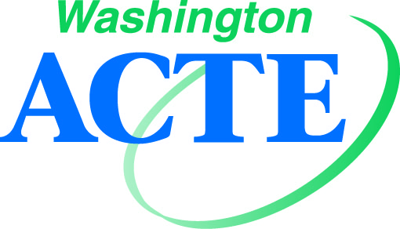
Conference Sponsorship Program 2022
Contact Tim Knue, Executive Director: tim@wa-acte.org / 360-202-5297

Your sponsorship will bring your name to front lines of CTE professionals and highlight you as an avid supporter of Career and Technical Education in Washington State.
Request Sponsorship early to secure the best opportunity for your company or organization!

Summer Conference
August 7-10, 2022
The Davenport Grand Hotel, Spokane WA
In-Person or Remote
900+ attendees anticipated

Bronze Level Sponsorship - $1,000  - Recognition on WA-ACTE website and in conference program digital app (Whova).  - Single exhibit space.  - Participation in the “Exhibitor” digital tools in the conference app.  - One breakout session available Sunday afternoon as space is available at time of session submitted.  - One pre- or post-Summer Conference email distribution of approved information to all attendees’ email addresses through Summer Conference management app. | Silver Level Sponsorship - $3,000  - Silver and above Sponsor(s) receive name recognition for sponsorship during the Washington ACTE awards session honoring leaders and award winners.  - Signage in the exhibit hall on conference presentation screens and on WA-ACTE website.  - Participation in both the “Exhibitor” (Whova) and “Sponsor’s” (Whova) digital tools in the conference app.  - Double exhibit space, if requested, and available at time of payment.  - One additional breakout session available Sunday afternoon as space is available at time submitted. (two possible).  - Total of three pre- or post-Summer Conference email distribution of approved information to all attendees’ email addresses through Summer Conference management app.
Gold Level Sponsorship - $5,000  - All Bronze and Silver benefits plus…  - Receive name recognition in general sessions.  - Display of a Sponsor-produced 2-minute video at the Opening Session.  - Logo representation on conference presentation screens, event signage where available, digital conference app, and on WA-ACTE website.  - Total of five pre- or post-Summer Conference distribution of approved information to all attendees’ email addresses through Summer Conference management app. | Platinum Level Sponsorship – $10,000+  - All Bronze/Silver/Gold benefits plus...  - Display of a Sponsor-produced 2-minute video at the opening of two general sessions.  - Negotiated general session speaking time/opportunity at Summer Conference.  - TBD, via previous conversation(s) if available/doable by conference limitations.
Conference Sponsorship Program 2022
Registration Form

- $1,000 Bronze Level Sponsorship

- $3,000 Silver Level Sponsorship

- $5,000 Gold Level Sponsorship

- $10,000+ Platinum Level Partnership

Main Contact Name:

Main Contact Email:

CC Email:

Phone Number:

Company Name (signs will be made as submitted):

Address:

City/State/ZIP:

Onsite Name(s) for Badges:

Check Payable to: WA-ACTE
Mail to: PO Box 315, Olympia WA 98507-0315
Fax: 360-357-1491
Email: taa@wa-acte.org
To pay by credit card, go to: https://wa-acte.regfox.com/2022-wa-acte-summer-conference (4% fees apply)

