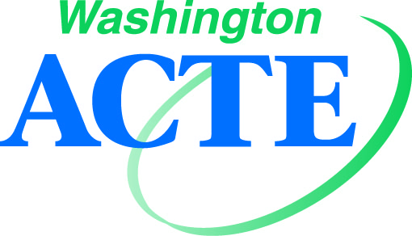
Conference Sponsorship Program 2020
Contact Tim Knue, Executive Director: tim@wa-acte.org / 360-202-5297

All sponsorships include/apply for both of the Washington ACTE hosted conferences for 2020. Your sponsorship will bring your name to front lines of CTE professionals, and highlight you as an avid supporter of Career and Technical Education. Sponsor early to secure the best opportunity for your company or organization!

Summer Conference  August 2-5, 2020  Virtual  900+ attendees anticipated | Fall Conference  November 5-6, 2020  Great Wolf Lodge, Grand Mound/Centralia  300+ attendees anticipated  Table display only due to limited space.

Bronze Level Sponsorship - $3,000  The benefits of this level are:  - Single exhibit space  - One breakout session  - Recognition in opening session at conference  - Logo representation on conference presentation screen  - Logo representation on event signage  - Logo representation as a sponsor in conference program (digital app and/or paper)  - Logo representation on Washington ACTE website as a conference sponsor | Silver Level Sponsorship - $5,000  The benefits of this level are:  - Bronze level benefits + the following  - Double exhibit space or end cap  - Two breakout sessions  - Breakfast sponsorship listing (subject to availability – see Gold option)
Gold Level Sponsorship - $15,000  The benefits of this level are:  - Silver level benefits + the following  - Sole sponsorship of breakfast session and welcome  - Must be arranged in a timely manner in order to fully plan and market the conference  - Maximum of four breakouts  - Link to article and/or blog posting featured on landing page of Washington ACTE website | Platinum Level Sponsorship – $20,000+  The benefits of this level are:  - Gold level benefits + the following  - Negotiated general session speaking time at Summer Conference
Conference Sponsorship Program 2020
Registration Form

- $3,000 Bronze Level Sponsorship

- $5,000 Silver Level Sponsorship

- $15,000 Gold Level Sponsorship

- $20,000+ Platinum Level Sponsorship

Main Contact Name:

Main Contact Email:

CC Email:

Phone Number:

Company Name (signs will be made as submitted):

Address:

City/State/ZIP:

Onsite Name(s) for Badges:

Check Payable to: WA-ACTE
Mail to: PO Box 315, Olympia WA 98507-0315
Fax: 360-357-1491
Email: taa@wa-acte.org

