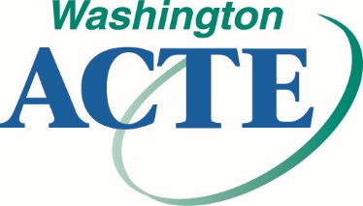
WA-ACTE ACHIEVE 100% MEMBERSHIP AWARD

WA-ACTE’s Achieve 100% Membership Award recognizes schools and institutions that have 100% WA-ACTE membership participation from each and every member of their Career and Technical Education staff. The award will be presented at the annual WA-ACTE Summer Conference.

How to Participate
Simply submit a list of all your school’s eligible Career and Technical Education personnel staff. WA-ACTE staff will verify membership status. Participating personnel must be active WA-ACTE members at time of application.

WA-ACTE ACHIEVE 100% MEMBERSHIP AWARD REPORTING FORM

School/Institution
Address
City/State/ZIP
CTE Director
Phone Number
Fax Number
Email

CTE Staff Names: WA-ACTE Membership #:
1.
2.
3.
4.
5.
6.
7.
8.
9.
10.
11.
12.
13.
14.
15.

Attach Additional Names if Necessary

Mail to: WA-ACTE, PO Box 315, Olympia WA 98507-0315
Fax to: 360-357-1491
Email to: taa@wa-acte.org
Deadline: May 1, 2019

